Weekly Homework Log

Week of ____________________

____

________________________________





**Be a Homework Superhero!**

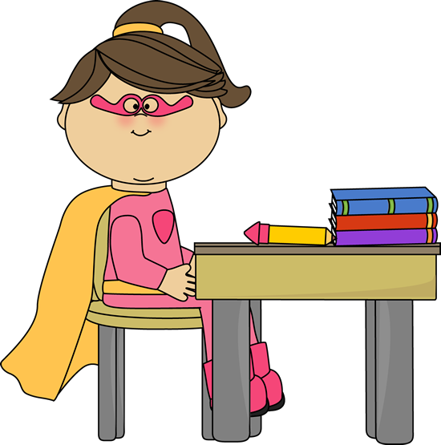

**Get your Superpowers ready for homework!**

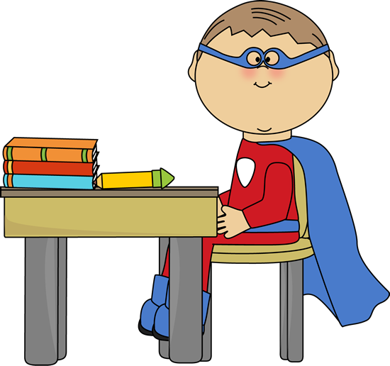

|  |  |  |  |  |  |
| --- | --- | --- | --- | --- | --- |
|  | **I Read for _____**  **minutes.** | **Spelling**  **Words** | **Sight**  **Words** | **Math Homelink**  **(if sent home)**  **and/or math facts** | **Xtramath**  **(optional)** |
| **Monday** |  |  |  |  |  |
| **Tuesday** |  |  |  |  |  |
| **Wednesday** |  |  |  |  |  |
| **Thursday** |  |  |  |  |  |
| **Friday** |  |  |  |  |  |
| **Saturday**  **\*Bonus\*** |  |  |  |  |  |
| **Sunday**  **\*Bonus\*** |  |  |  |  |  |

________________________________________ ___________________________________________

Student Signature Parent Signature

Name___________________________________

My homework is done!



Daily Reading

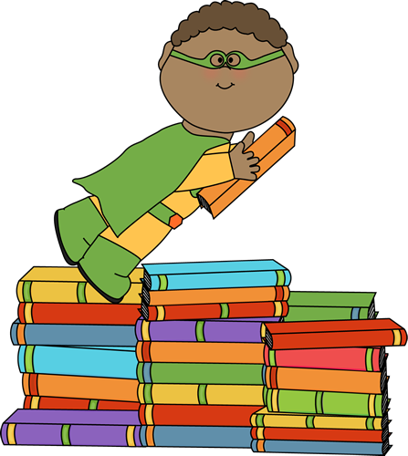

Reading at home is **important**! Your child may read to you, you may read to your child, or you may read together. Please record the number of minutes you and your child read each day on your child’s Homework Hero Chart. Below are a few tips on reading with your child.

* Read to your child everyday for at least 15 minutes.
* Discuss the title and predict what the book might be about.
* Let your child help turn the pages.
* Encourage your child to read with you.
* Let your child see you reading.
* Have your child guess the ending.
* Ask lots of questions about the book.
* Look at the pictures and talk about them.
* Act out the story.

**Dog,**

**D-O-G, Dog**

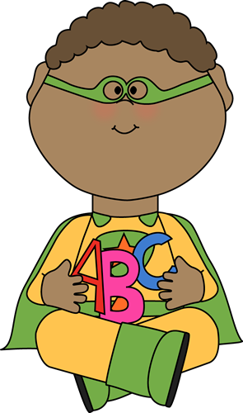

Spelling

Spelling lists will be sent home on Mondays after the spelling pattern and words have been introduced in class. Please see below for suggested activities. Spelling will be assessed at the end of each week through dictation. Please remember that your child should be learning the spelling pattern, rather than just memorizing the words.

1. Sort the words by patterns: example: _at, _ad, _ap

Can your child think of additional words to list under each pattern?

1. Write words in sand, table salt, or shaving cream.
2. Spell the words using Play-Doh or Wikki Sticks.
3. Cut letters out of newspapers or magazines to spell your words. Paste them on a piece of paper.
4. Paint your words on a piece of paper.
5. Play charades with your words. Have a family member act out the word. The child must not only guess the word, but spell it correctly!
6. Put your words in ABC (alphabetical) order.
7. Can you think of any other activities you can do with your spelling words?

_at _ad _ap

Cat dad cap

Mat had **1**

**2**

**3** 

**4**

**5**



**7**

**8**

**6**

Sight Words



and



the

Sight words will be sent home on Mondays with the Spelling list. The words will have been introduced in class that day. Please see below for activities your child can do to help learn these words.

1. Word Hunt: Look in newspapers or magazines for each week’s sight words. Cut them out and glue them on a piece of paper. Read each word at least 3 times.
2. Write your words on index cards and put them on a ring. Practice reading the words on your ring (bring them in the car, read them quickly before bed, etc.) If you don’t have a ring—let me know! I have plenty to share!
3. Rainbow write your sight words. Get several different color crayons or colored pencils. Write your sight words on a piece of paper with a pencil. Then trace over them with each color. Say the word, spell the word, and then say the word again as you write them.
4. Spell the words using Play-Doh or Wikki Sticks.
5. Write sentences using your sight words. Underline the sight word in each sentence.
6. Paint your words on a piece of paper. Read each word at least 3 times.
7. Place a sight word card on each step leading upstairs. Read each word on your way upstairs to bed! (If you don’t have stairs in your home, you can just lay the cards in a path on the floor leading to your bedroom!)
8. Have a family member hide several of your sight words. As you find each word, you must read it in order to keep it. Score 1 point for each word you find *and* read correctly.
9. Can you think of any other activities you can do with your sight words?

**4**

**2**

**3** 

**1**

**5**

**7**

He likes dogs.

Dogs are fun.

**6**

**8**